Experiment –1

ER DIAGRAM OF COLLEGE DATABASE

Aim: To draw a er diagram of college database

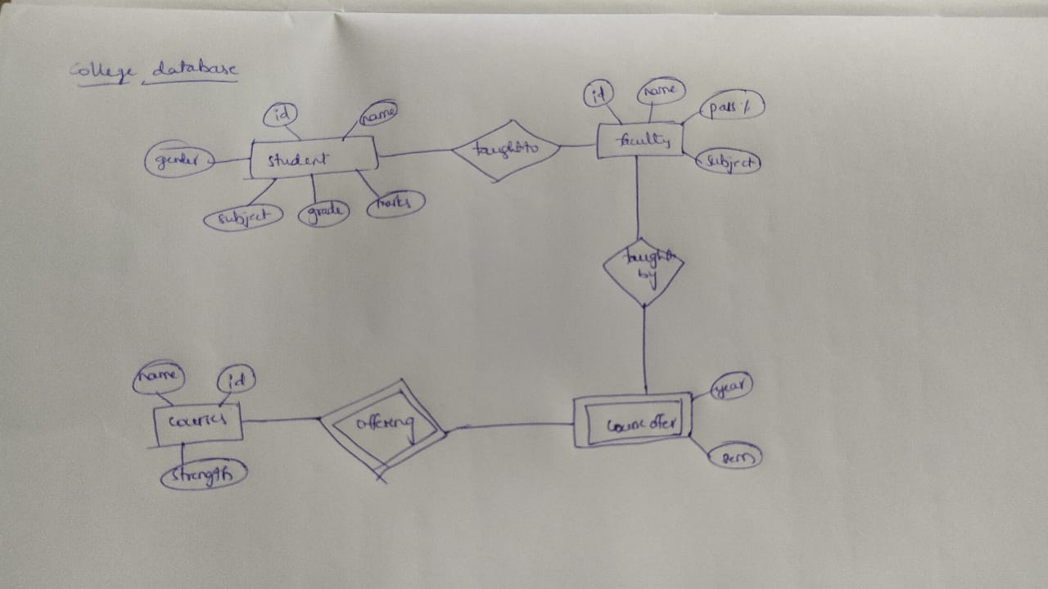

Experiment-2

ER DIAGRAM FOR SAILOR BOAT DATABASE

Aim: Draw an ER diagram of sailor boat database

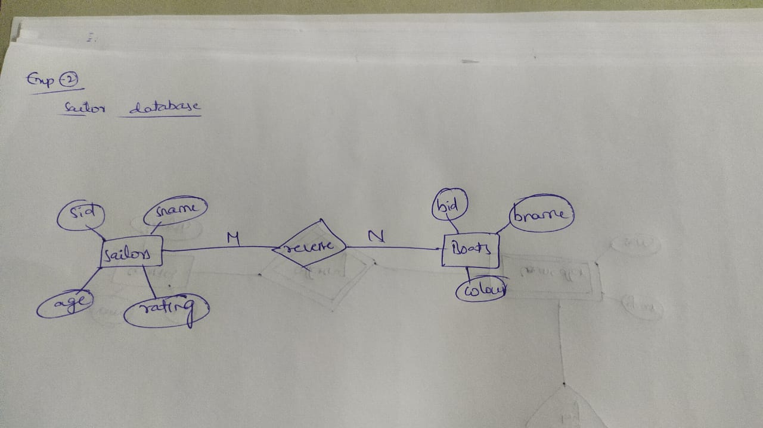

Experiment-3

RELATIONAL MODEL FOR COLLEGE DATABASE

Aim: Draw a relational model for a college database

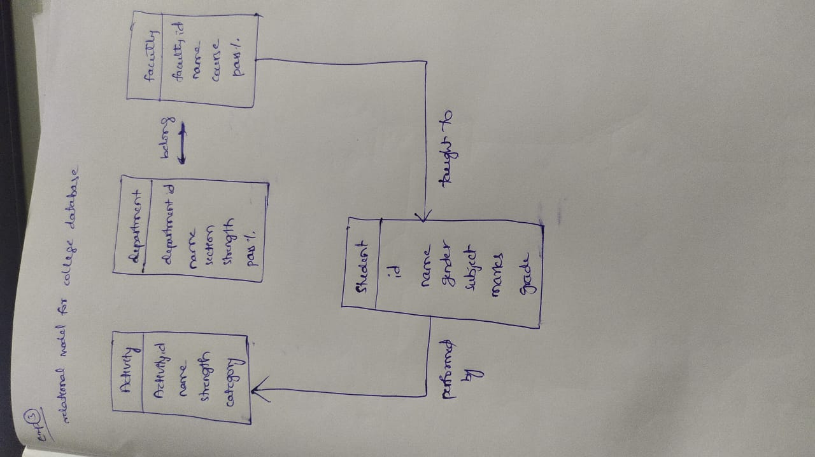

Experiment-4

RELATIONAL MODEL FOR SAILOR BOAT DATABASE

Aim: Draw a relational model for a sailor boat database

